The Road to Platinum Koi (from Cape Town)

You have two options: Via the N2 over Sir Lowry's Pass, across the Overberg passing Caledon and Riviersonderend and turning left at Stormsvlei. Through the pass and turn left at Langverwacht sign. Five km further turn left at the little board pointing to McGregor. Turn left at the T-junction, through the Boesmans river dip, and 4km further turn left at the "Pikkie" sign.
Alternatively: Travel with the N1 through the Hugenot tunnel to Worcester and turn right onto route R60 towards Robertson.
On passing Robertson turn right at the circle onto the R317 towards Bonnievale. If you reset your route counter here to zero, the following will guide you through the heart of the Breede River valley with its roses, bougainvillea and Canna indica, horse stud farms, fruit orchards and vineyards. Many wine farms of note. Springfield at 2.5km, Bon Courage at 7.0km, Van Loveren at 12.4km and De Wetshof a stone throw further. (It is worth noting that in the Robertson -Bonnievale area there are more than 40 wine cellars all offering a taste of their product for free.)
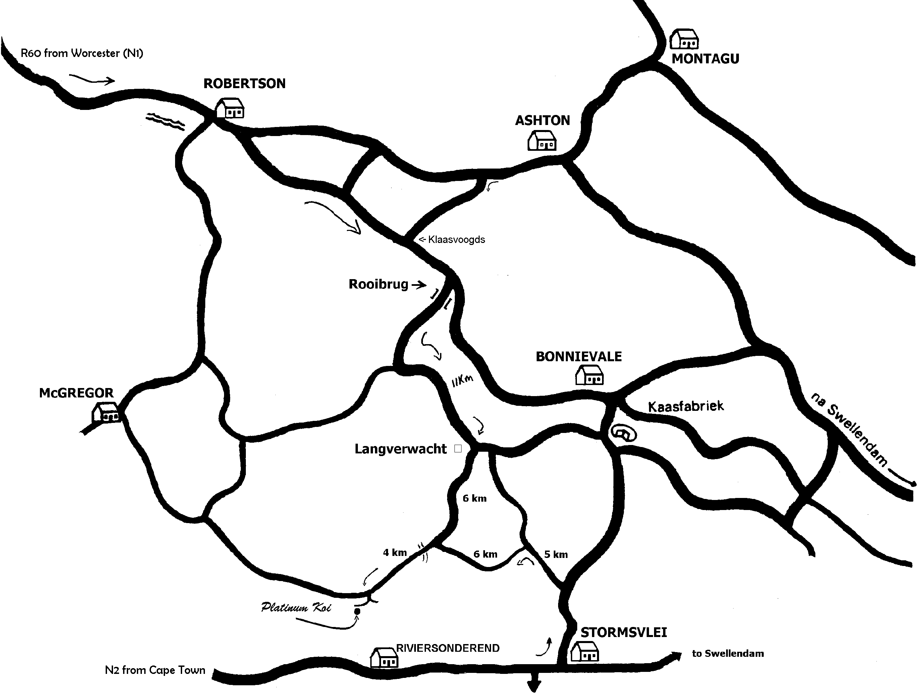
Turn right at the 14.3km mark staying on the R317 towards Stormsvlei and crossing the Breede River with the narrow gauge Rooibrug a little further. On the way you'll pass a large ostrich grower on the left and vineyards as far as the eye can see.

At 25.4km you should be at Langverwacht. Turn right toward Boesmansrivier and McGregor and cross the Boesmans River at 32.0km, leaving the tar for some not-too-bad dirt road.
At 35.7km turn left at the tractor tire named Pikkie, amble along (do not turn off left) on a bad road, through a motor gate and find Platinum Koi where the parking is safe. (Your route counter should stand on 36.9km providing your vehicle's tyres are worn to the same level as mine.)
While both routes are about the same distance from Cape Town centre, I suggest the latter:
Please note: At Worcester turn right at the first or third robot. (Second robot closed due to road works)

